Coding Test

Altair Issametov [altair.issametov@gmail.com](mailto:altair.issametov@gmail.com)

# Program Review

Programming language: C++11.

Besides C++, CMake file “CMakeLists.txt” has been made easier manipulation with source code and header files

The program summary is illustrated in Figure 1 given below. The summary includes only essential functions to manipulate with data disregarding “getter” functions.

It consists of multiple objects for correct and easier data manipulation. For example, DataParser has been allocated for manipulation with files, such as reading the entire file or a limited number of rows of the file. As a result, it provides easier unit testing of the program. Indeed, for multiple files parsing, the same instances of other objects can be used.

OrderTable represents a hashmap of stock symbols as a key and OrderBook as a value. Considering the file includes 100 stocks, it is essential to allocate each order to a specific OrderBook for preventing overriding the existing instance of the OrderBook and preventing loss of data. Additional functions, such as getLongestTimeTrade() and getLongestTimeTick(), consider longest times between trades and ticks of every stock to provide more information regarding stock market.

OrderBook represents a vector of order or rows for each specific stock. Therefore, it provides grouping of the stock and easier parsing of orders with common symbols. In addition, upon allocation of the order in the list, the mean and median tick time are updated instantaneously, due to storage of previous bidPrices and askPrices. Moreover, other statistical data, such as mean, median, and the longest time between trades are also updated upon adding new order, as well as mean and median bid-ask spread. Therefore, it accelerates the parsing of Orders without additional iteration after file parsing as shown in Figure 2.

Order represents each row in the csv file. The attributes of the object represent each value of order per column and are named accordingly.

# Program Build Guidelines using CMake

1. Create a “build” directory inside your project directory.
2. Please navigate to the build directory using the command line.
3. Using terminal please enter “cmake /path/to/project_directory”.

# Limitations

1. For this program, CMake and GCC as active kits have been used. Therefore, it is suggested to provide a full path to the data and destination files.
2. The program requires approximately 18 seconds for parsing 80 000 orders, which can be found insufficient. Therefore, further research on acceleration of data parsing will be conducted.

# Results

The sample results of parsing data are given in the file “data.csv” in the format shown in Figure 3 below. Based on the retrieved 80000 results, it can be concluded that:

1. Overall Longest Time between Trades: DETNOR NO Equity|360.0000 seconds
2. Overall Longest Time between Tick: AKSO NO Equity|495.0000 seconds

This data presents that among all stocks DETNOR NO Equity has the longest time between trades and AKSO NO Equity has the longest time between ticks.

There are more conclusions that can be made upon careful consideration of all 13 million orders.

In addition, for easier visualization of the data in the terminal, the same format as in “data.csv” has been implemented as shown in Figure 4.

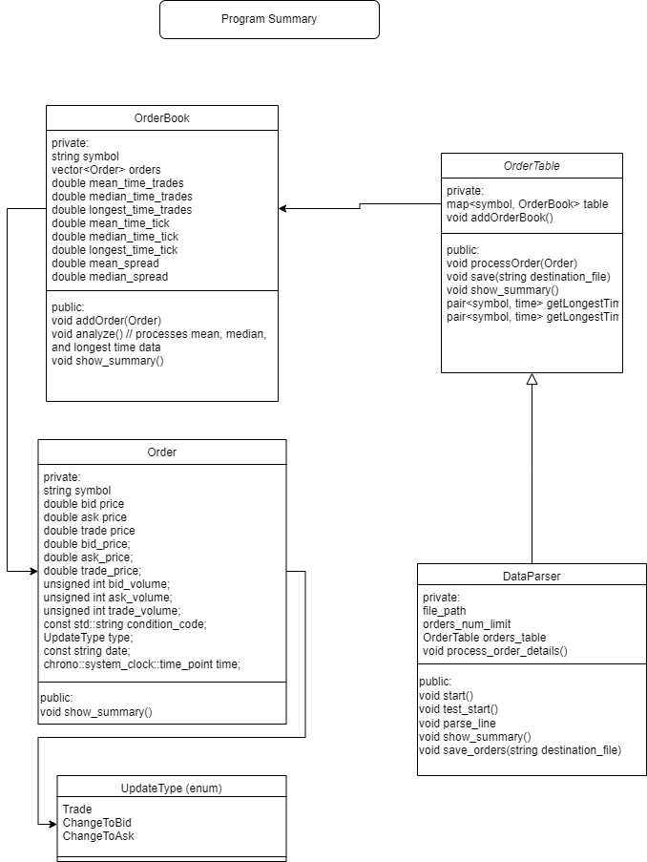

Figure 1. Program Summary.

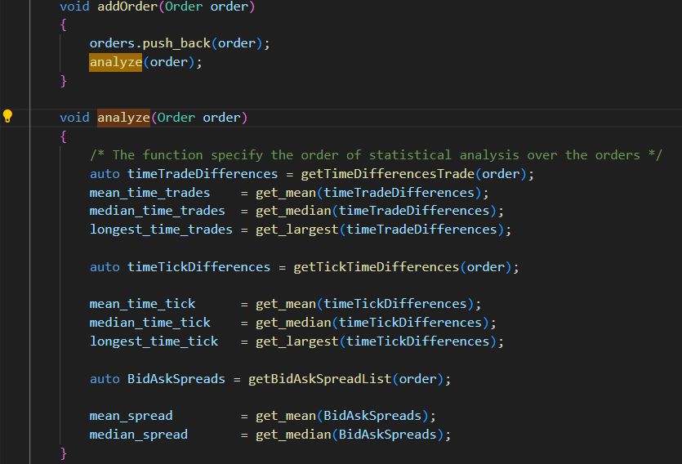

Figure 2. Analyze() member function of OrderBook object.

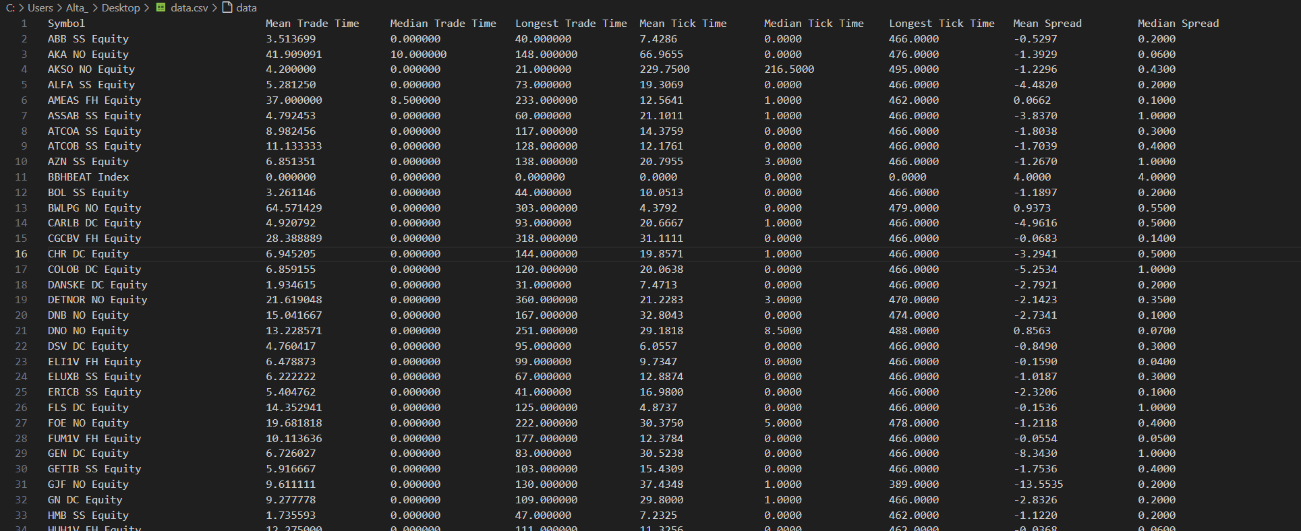

Figure 3. Sample results format in “data.csv”.

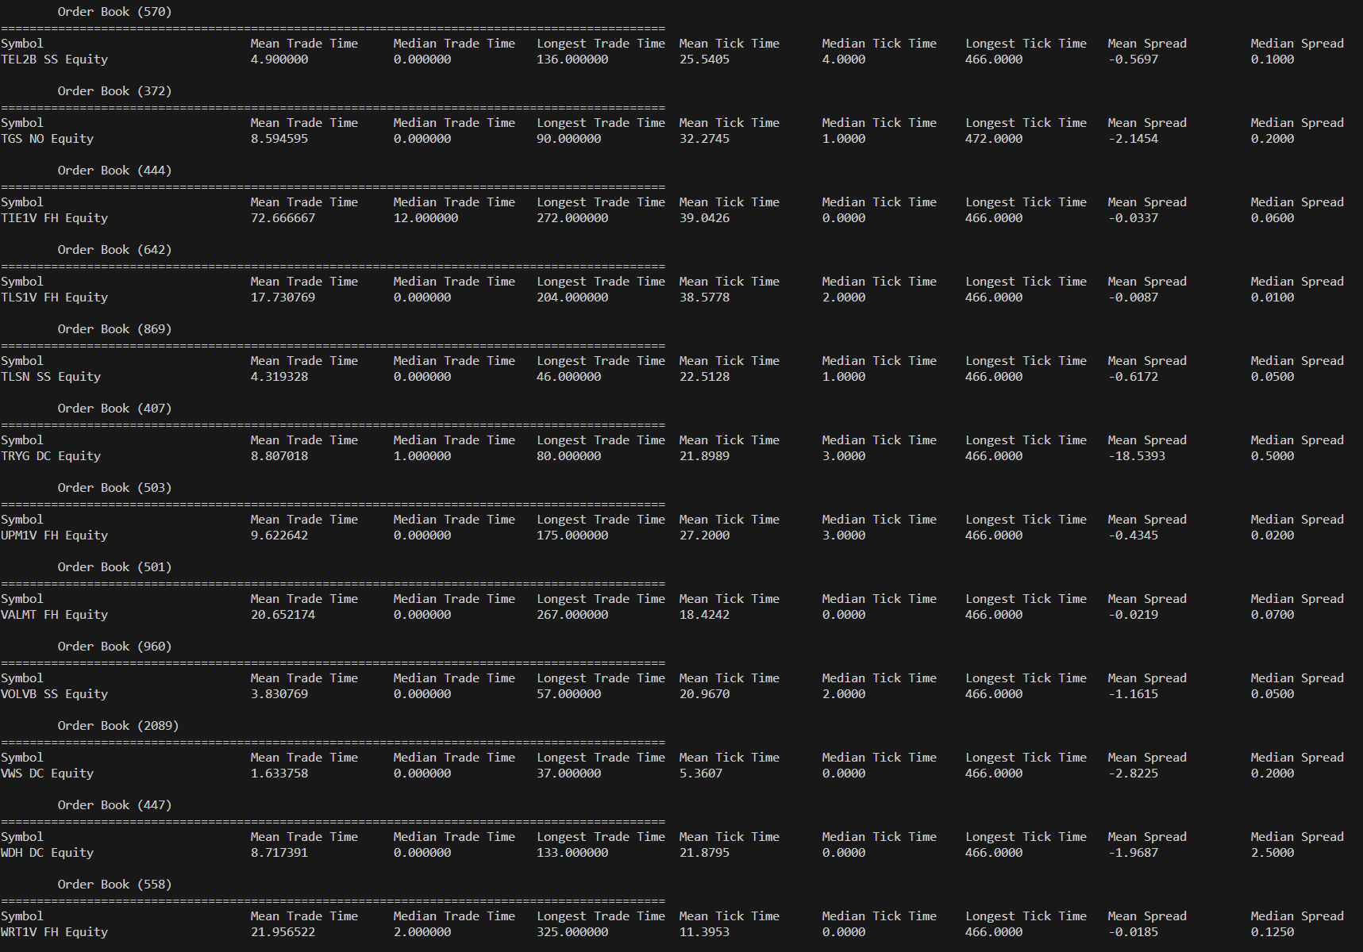

Figure 4. Sample data in the terminal for better visualization and testing.